**HORMISDALLEN SCHOOL - KYEBANDO**

**PRE- PLE SET 9 EXAMINATIONS, 2023**

**PRIMARY SEVEN SOCIAL STUDIES**

**Duration: 2 Hours 15 Minutes**

**NAME: ______________________________________________ STREAM: _________**

INDEX NO.

EMIS NO.

**SECTION A ( 40 MARKS)**

1. Name any **one** member of a nuclear family.

……………………………………………………………………………………………

2. Give any **one** reason why highland areas experience low temperature.

……………………………………………………………………………………………

3. State any **one** danger caused by wind to farmers.

……………………………………………………………………………………………

4. Draw a map symbol for a rift valley in the space provided below.

|  |
| --- |
|  |

5. How is a national constitution useful to citizens in Uganda?

……………………………………………………………………………………………

6. Name any **one** country which is a member of Economic Community of West African States (ECOWAS).

……………………………………………………………………………………………

7. Give any **one** way of controlling soil erosion in highland areas.

……………………………………………………………………………………………

8. Why was the Nandi revolt staged in East Africa?

……………………………………………………………………………………………

9. Name the missionary who introduced the first printing press in Uganda.

……………………………………………………………………………………………

10. Give any **one** reason why Namirembe Agreement was signed in Uganda in 1955.

……………………………………………………………………………………………

11. In which way do televisions promote trade in East Africa?

……………………………………………………………………………………………

12. How is a rubbish pit important in a school?

……………………………………………………………………………………………

13. What title is given to the head of police in our district?

……………………………………………………………………………………………

Study the diagram below and answer numbers **14** and **15.**

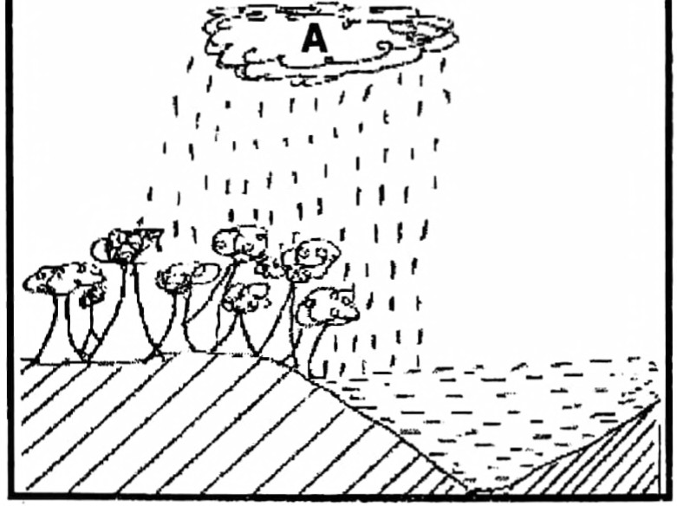

14. Name the type of rainfall represented in the diagram.

……………………………………………………………………………………………

15. Mention the process which takes place at **A.**

……………………………………………………………………………………………

16. What do we call the building where art facts and materials of long ago are kept?

……………………………………………………………………………………………

17. How is a carpenter important to people in our community?

……………………………………………………………………………………………

18. State **one** major cause of a low population in Northeastern Kenya.

……………………………………………………………………………………………

19. Name any **one** Island country located in West Africa.

……………………………………………………………………………………………

20. Give any **one** reason why citizens are encouraged to pay taxes.

……………………………………………………………………………………………

21. State any **one** role of Uganda Wildlife Authority (UWA)

……………………………………………………………………………………………

22. How is Uganda similar to Nigeria in terms of colonial history?

……………………………………………………………………………………………

23. Give any one way of promoting peace among people at home.

……………………………………………………………………………………………

24. Mention any one political contribution of the Bachwezi in East Africa.

……………………………………………………………………………………………

25. How were the mission stations important to missionaries during the spread of Christianity in East Africa?

……………………………………………………………………………………………

26. Who heads the Common Wealth of Nations?

…………………………………………………………………………………………….

27. State any one role of parents at home.

……………………………………………………………………………………………

28. How does the war in Somalia affect the neighbouring countries of East Africa?

……………………………………………………………………………………………

29. Mention the traditional name for lake Victoria in Uganda.

……………………………………………………………………………………………

30. Give any one effect of deforestation on climate.

……………………………………………………………………………………………

31. Name any one traditional means of communication

……………………………………………………………………………………………

32. Give any one way pupils can show love for their school.

……………………………………………………………………………………………

33. Which legend explains the origin of Baganda people in Uganda?

……………………………………………………………………………………………

34. Give any one reason why people in East Africa protects wild animals.

……………………………………………………………………………………………

35. Give any one way in which democracy is practiced in Uganda.

……………………………………………………………………………………………

**For numbers 36-40,answer Either Christianity or Islam but not both alternatives in a number.**

36. **Either:** Name any **one** example of Gospel writers in the Bible.

……………………………………………………………………………………………

**Or:** Name the book which was revealed to Prophet Isa in Islam.

……………………………………………………………………………………………

37. **Either:** Give any **one** reason why Christians pray before going to sleep at night.

……………………………………………………………………………………………

**Or:** Give any **one** reason why Moslems pray before going to sleep at night.

……………………………………………………………………………………………

38. **Either:** What lesson does a Christian learn from the story of Joseph and his brothers in Egypt?

……………………………………………………………………………………………

**Or:** What lesson does a Moslem learn from the story of Prophet Yusuf and his brothers in Egypt?

……………………………………………………………………………………………

39. **Either:** How many days did God take to complete the work of creation?

……………………………………………………………………………………………

**Or:** How many days did Allah take to complete the work of creation?

……………………………………………………………………………………………

40. **Either:** Mention any **one** role of the Holy Spirit in Church.

……………………………………………………………………………………………

**Or:** Mention the role of Angel Malik in Islam.

……………………………………………………………………………………………

**SECTION B (60Marks)**

**41. Study the coat of arms below and answer questions about** it.

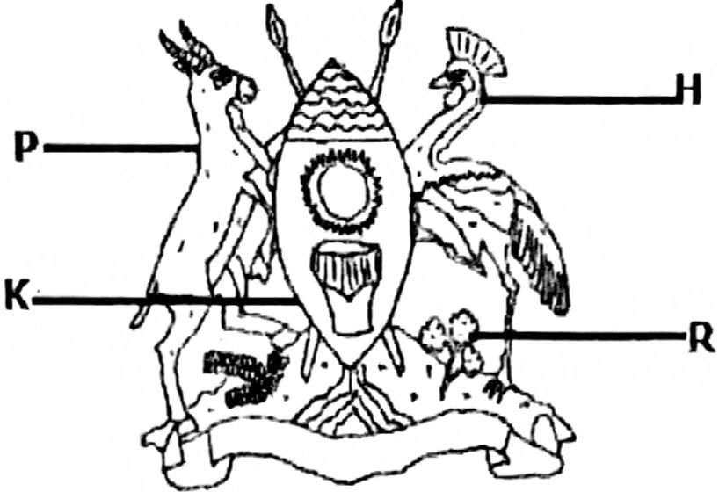

a) What does feature **P** represent on the coat of arms?

……………………………………………………………………………………………

b) Name the feature.

( i)**R**…………………………………………………………………………………………

(ii)**K**…………………………………………………………………………………………

c) Why does feature **H** stand on one leg forward?

……………………………………………………………………………………………

42a) Give any two benefits a school gets from the community.

i)……………………………………………………………………………………………

ii)……………………………………………………………………………………………

b) State any **two** advantages of fencing a school.

i)……………………………………………………………………………………………

ii)……………………………………………………………………………………………

43a) Name the African leader who organized the Accra Pan-African Conference of 1958.

……………………………………………………………………………………………

b) Give any **one** reason why African leaders attended the Accra Pan-African Conference .

……………………………………………………………………………………………

c) Mention any **two** problems Pan-Africanists faced in their struggle for freedom.

i)……………………………………………………………………………………………

ii)……………………………………………………………………………………………

44a) What is a swamp?

……………………………………………………………………………………………

b) Give any **two reasons** why people are encouraged to conserve swamps.

i)……………………………………………………………………………………………

ii)……………………………………………………………………………………………

c) State any **one** problem caused by draining swamps.

……………………………………………………………………………………………

45a). **Study the map and answer the questions about it.**

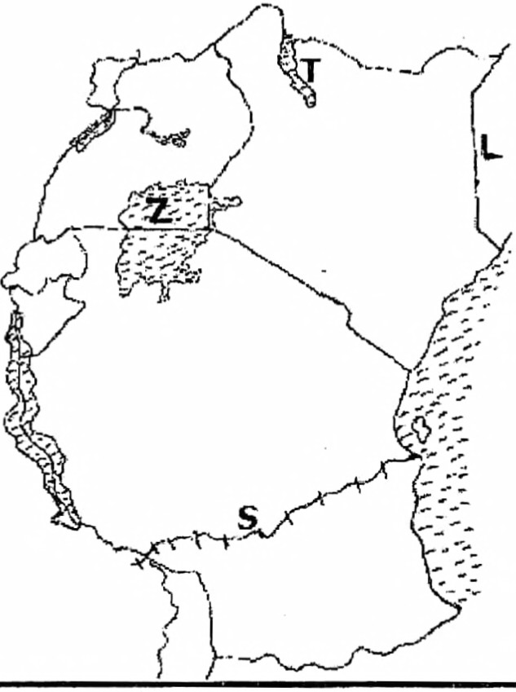

1. Name the country **L.**

……………………………………………………………………………………………

1. In which way is railway **S** important to Zambia?

……………………………………………………………………………………………

1. How was Lake **T** formed?

……………………………………………………………………………………………

1. Name the feature marked **Z .**

……………………………………………………………………………………………

46a). Name any two elements of a good map.

i)……………………………………………………………………………………………

ii)……………………………………………………………………………………………

b) Give one reason why it is easy to understand a picture of an object.

……………………………………………………………………………………………

c) Draw a picture of a pot in the space below.

|  |
| --- |
|  |

47a) Give one example of a block mountain in Uganda.

……………………………………………………………………………………………

b) How were Block mountains formed?

……………………………………………………………………………………………

c) State any two importance of mountains to people.

i)……………………………………………………………………………………………

ii)……………………………………………………………………………………………

48a) Mention any two tribes in East Africa that participated in Long Distance Trade.

i)……………………………………………………………………………………………

ii)……………………………………………………………………………………………

b) Name any two items of trade that were taken from the interior of East Africa during Long Distance Trade.

i)……………………………………………………………………………………………

ii)……………………………………………………………………………………………

49**. Study the map of Africa below and answer questions about it.**

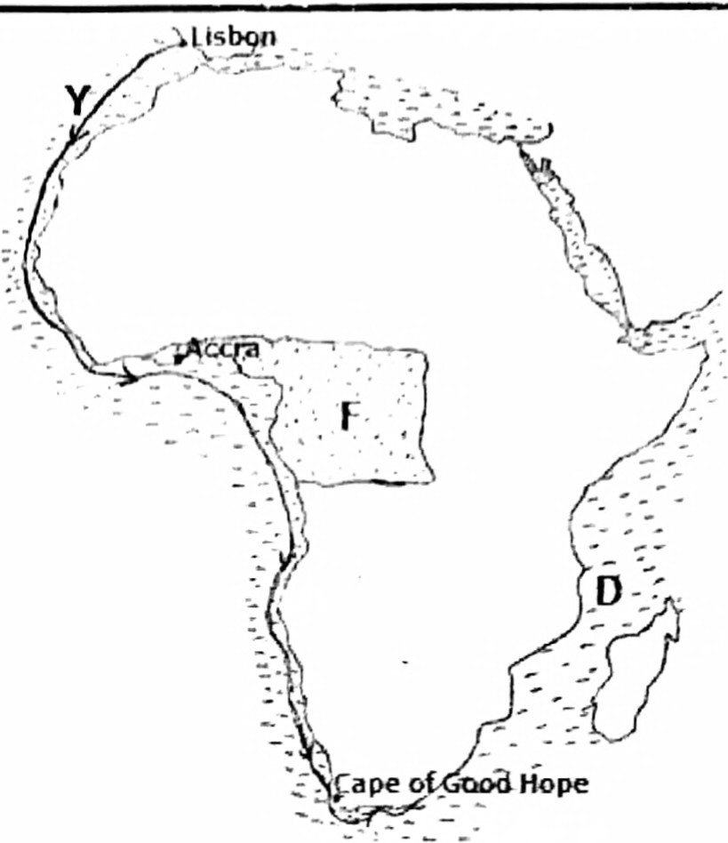

1. Mention the European explorer who used route Y.

……………………………………………………………………………………………

1. Name the water body marked D.

……………………………………………………………………………………………

1. State any **one** characteristic of shaded vegetation zone F.

……………………………………………………………………………………………

1. **Draw the Prime Meridian on the map.**

50a). Give any **two** examples of information collected during population census.

i)……………………………………………………………………………………………

ii)……………………………………………………………………………………………

b) Give any **one** way how citizens benefit from population census.

……………………………………………………………………………………………

c) State any **one** problem faced by enumerators during population census

……………………………………………………………………………………………

**For numbers51 - 55. answer either Christianity or Islam but not both alternatives in a number.**

**51. Either:** a) Who was the earthly father of Jesus Christ?

…………………………………………………………………………………………

b) Give any **two** ways in which Jesus suffered after being arrested.

i)…………………………………………………………………………………………

ii) …………………………………………………………………………………………

c) State any **one** cause of suffering among Christians.

…………………………………………………………………………………………

**OR:** a) Who was the father of Prophet Muhammad (PBUH)?

…………………………………………………………………………………………

b) Give any **two** ways in which Prophet Muhammad suffered when he became a Prophet.

i)…………………………………………………………………………………………

ii)…………………………………………………………………………………………

c) State any **one** cause of suffering among Moslems.

…………………………………………………………………………………………

**52. Either:** a) Which day marks the start of fasting period for Christians?

…………………………………………………………………………………………

b) State any **two** reasons why Christians fast.

i)…………………………………………………………………………………………

ii)…………………………………………………………………………………………

c) Give any **one** way how a Christian observes fasting period.

…………………………………………………………………………………………

**OR:** a) What marks the start of fasting period in Islam?

…………………………………………………………………………………………

b) State any **two** reasons why Moslems fast.

i)…………………………………………………………………………………………

ii)…………………………………………………………………………………………

c) Give any **one** way how a Moslem observes fasting period.

…………………………………………………………………………………………

**53. Either:** a) Name the special week day when most Christians go to Church for worship.

…………………………………………………………………………………………

b) Give any **three** ways in which Christians participate in Church worship.

i)…………………………………………………………………………………………

ii)…………………………………………………………………………………………

iii)…………………………………………………………………………………………

**OR:** a) Name the special week day when Moslems go to the Mosque for worship.

…………………………………………………………………………………………

b) Give any **three** ways in which Moslems in the Mosque participate in worship.

i)…………………………………………………………………………………………

ii)…………………………………………………………………………………………

iii)…………………………………………………………………………………………

**54. Either:** a) Name the day when Christians celebrate Jesus' triumphant entry in Jerusalem.

…………………………………………………………………………………………

b) Why was Jesus not happy when he entered the temple in Jerusalem?

…………………………………………………………………………………………

c) Give any **two** ways how Jesus showed unhappiness when He entered the temple in Jerusalem.

i)…………………………………………………………………………………………

ii)…………………………………………………………………………………………

**OR:** a) Who was the first woman to convert to Islam?

…………………………………………………………………………………………

b) Why was Prophet Muhammad not happy with the way of worship of the Quraysh?

…………………………………………………………………………………………

c) Give any **two** ways how the Quraysh showed unhappiness for Prophet Muhammad (PBUH).

i)…………………………………………………………………………………………

ii)…………………………………………………………………………………………

**55. Either:** a) Name any **one** type of marriage accepted in Uganda.

…………………………………………………………………………………………

b) Give any **two** reasons why Christians marry.

i)…………………………………………………………………………………………

ii)…………………………………………………………………………………………

c) State **one** reason why people below eighteen years are not allowed to marry in Uganda.

…………………………………………………………………………………………

**OR:** a) Name any **one** type of marriage accepted in Uganda.

…………………………………………………………………………………………

b) Give any **two** reasons why Moslems marry.

i)…………………………………………………………………………………………

ii)…………………………………………………………………………………………

c) State **one** reason why people below eighteen years are not allowed to marry in Uganda.

…………………………………………………………………………………………

**THE END**